Test Case: tc001_SPX_Dev5_Crear_Solicitud_Articulo_Almacen
Step 1 - Enter username and password and click to button Enter : Credentials Entered
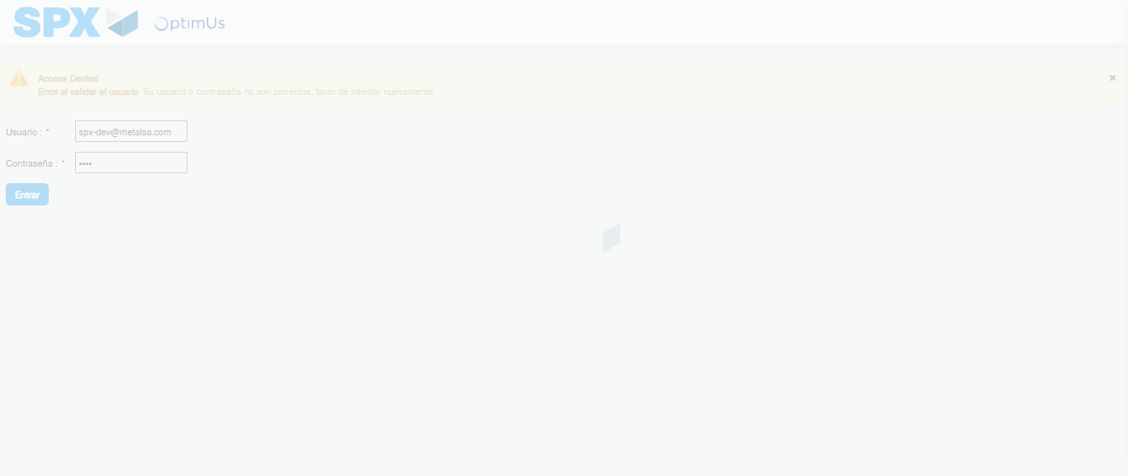Image file-name: QC_Testing-tc001_SPX_Dev5_Crear_Solicitud_Articulo_Almacen-1787939121737

Step 2 - Select to UEN and Access to Request for a New Inventory Item : UEN Correctly selected and Correct access
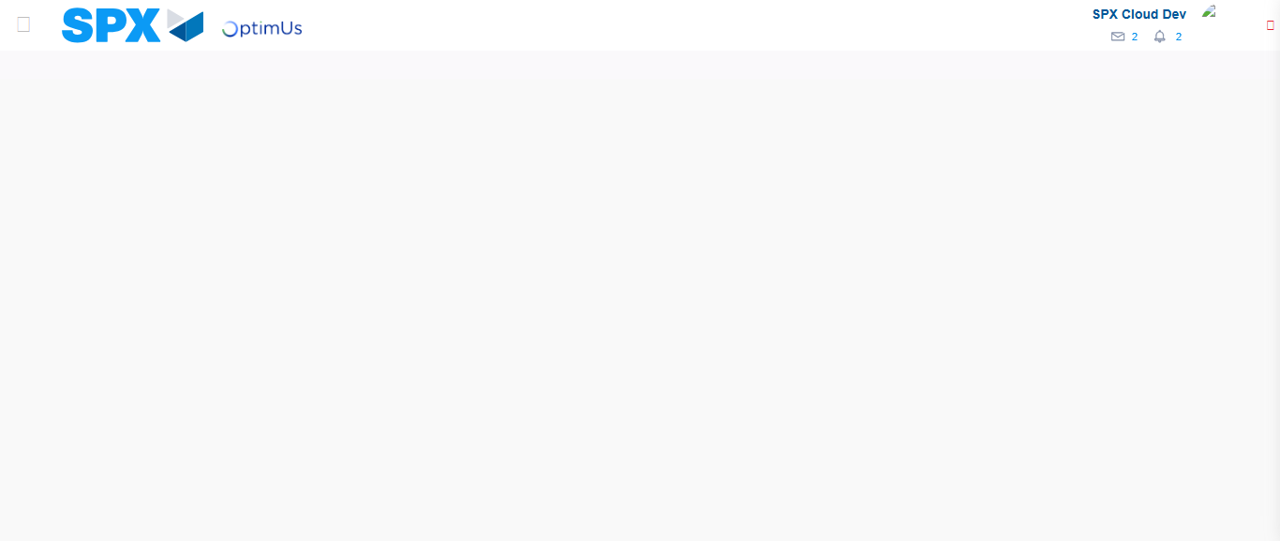Image file-name: QC_Testing-tc001_SPX_Dev5_Crear_Solicitud_Articulo_Almacen-1787939164985

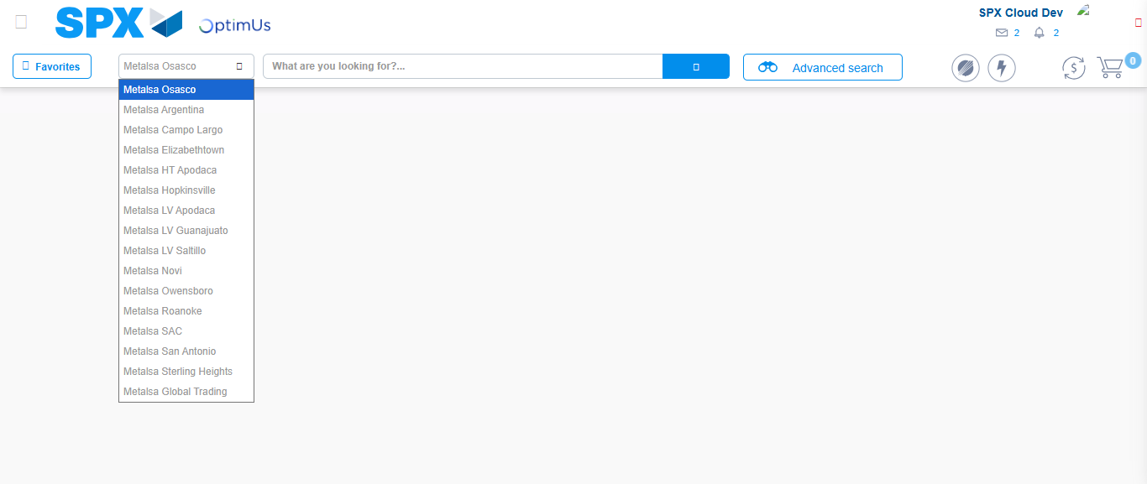Image file-name: QC_Testing-tc001_SPX_Dev5_Crear_Solicitud_Articulo_Almacen-1787939172095

Image file-name: QC_Testing-tc001_SPX_Dev5_Crear_Solicitud_Articulo_Almacen-1787939179295

Step 3 - Select options first section : Options seleted correctly
Image file-name: QC_Testing-tc001_SPX_Dev5_Crear_Solicitud_Articulo_Almacen-1787939179519

Image file-name: QC_Testing-tc001_SPX_Dev5_Crear_Solicitud_Articulo_Almacen-1787939179681

Step 4 - Select options at Screen: Options seleted correctly
Image file-name: QC_Testing-tc001_SPX_Dev5_Crear_Solicitud_Articulo_Almacen-1787939179519

Image file-name: QC_Testing-tc001_SPX_Dev5_Crear_Solicitud_Articulo_Almacen-1787939179681

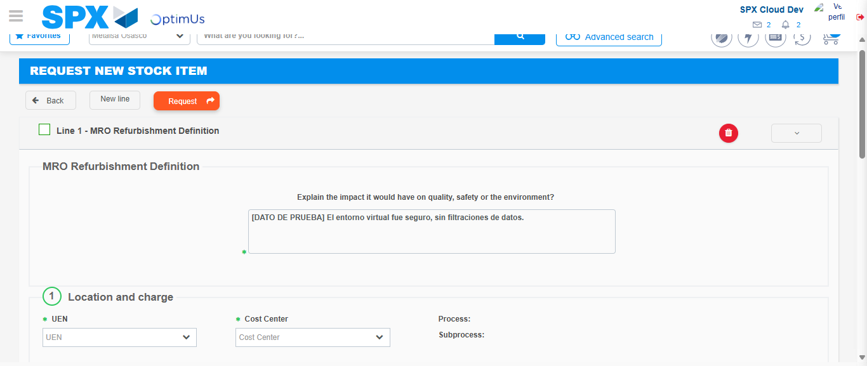Image file-name: QC_Testing-tc001_SPX_Dev5_Crear_Solicitud_Articulo_Almacen-1787939191377

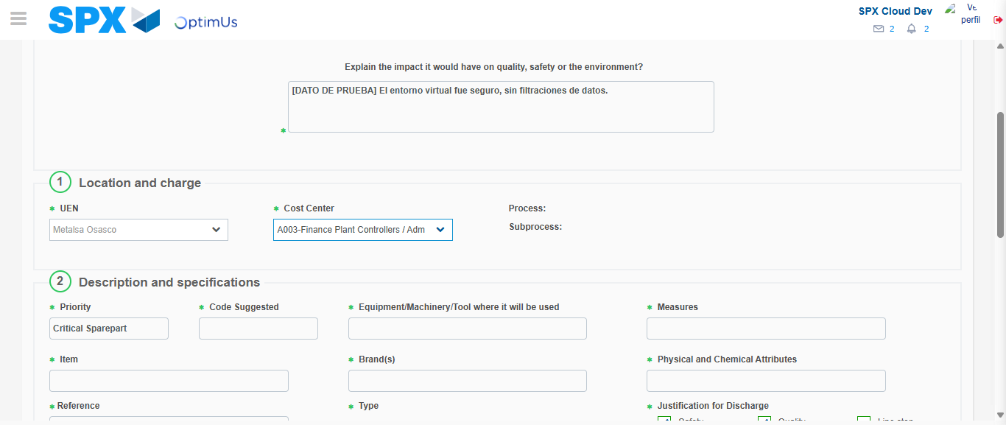Image file-name: QC_Testing-tc001_SPX_Dev5_Crear_Solicitud_Articulo_Almacen-1787939193682

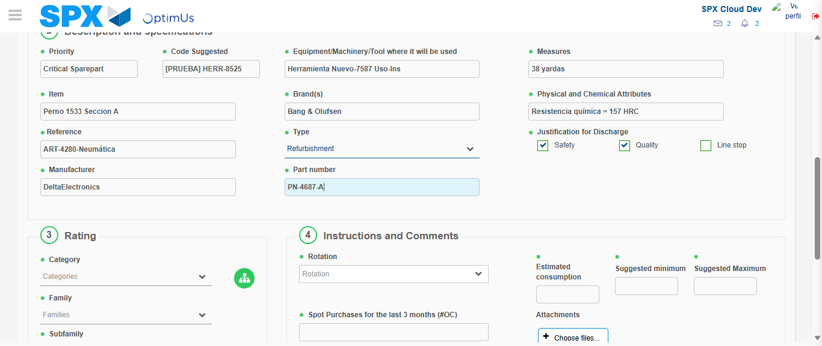Image file-name: QC_Testing-tc001_SPX_Dev5_Crear_Solicitud_Articulo_Almacen-1787939195037

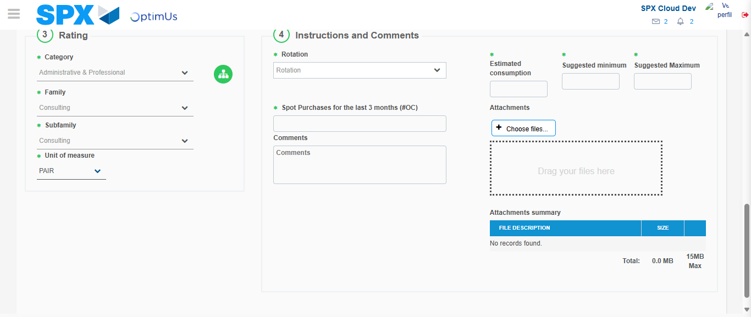Image file-name: QC_Testing-tc001_SPX_Dev5_Crear_Solicitud_Articulo_Almacen-1787939199132

Step 5 - Request New Item : Request Accepted
Image file-name: QC_Testing-tc001_SPX_Dev5_Crear_Solicitud_Articulo_Almacen-1787939164985

Image file-name: QC_Testing-tc001_SPX_Dev5_Crear_Solicitud_Articulo_Almacen-1787939172095

Image file-name: QC_Testing-tc001_SPX_Dev5_Crear_Solicitud_Articulo_Almacen-1787939179295

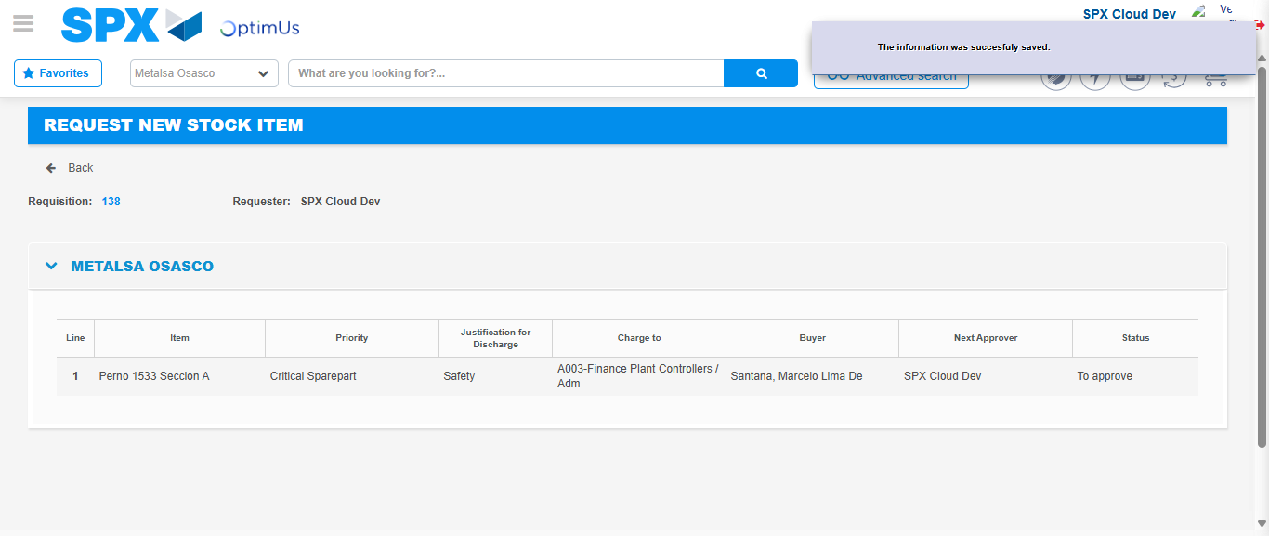Image file-name: QC_Testing-tc001_SPX_Dev5_Crear_Solicitud_Articulo_Almacen-1787939206033

Image file-name: QC_Testing-tc001_SPX_Dev5_Crear_Solicitud_Articulo_Almacen-1787939206203

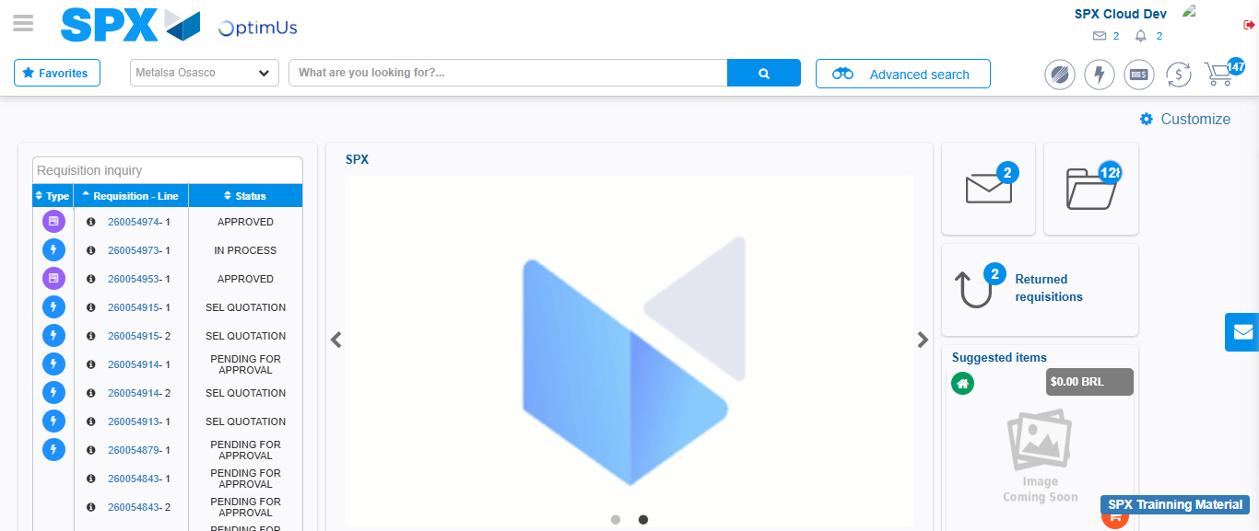Image file-name: QC_Testing-tc001_SPX_Dev5_Crear_Solicitud_Articulo_Almacen-1787939227619

Step 7 - Return to Main Page SPX : Return to Main Page SPX
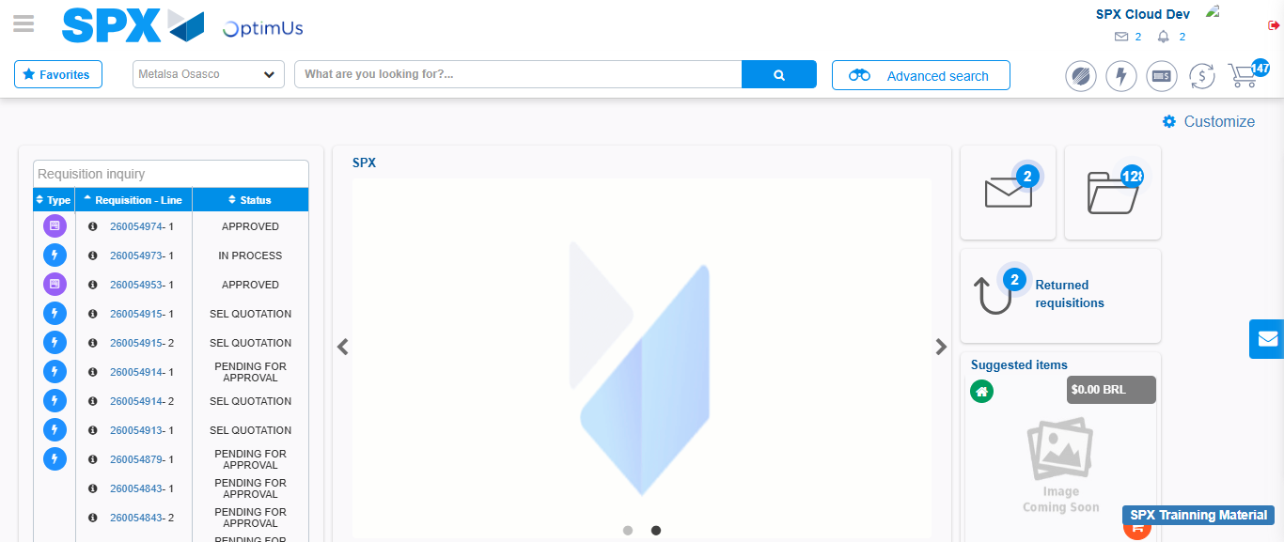Image file-name: QC_Testing-tc001_SPX_Dev5_Crear_Solicitud_Articulo_Almacen-1787939227982

